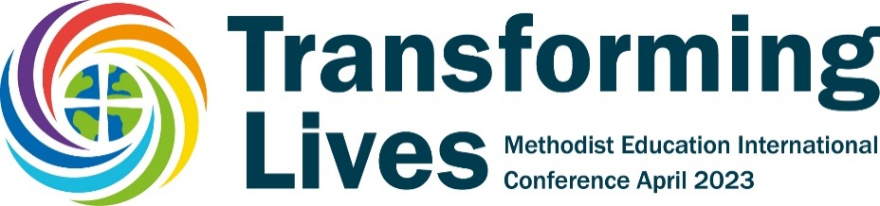
A Call to Holistic Global Education
The concept of holism and holistic education refers to a worldview or theoretical position that opposes reductionism, positivism, and the Cartesian dualism of self and world with an emphasis on the ultimate unity, relatedness, and inherent meaningfulness of all existence.
As part of the 2023 celebration of IAMSCU’s 30th anniversary and the Transforming Lives Methodist Education International Conference, Wesley House, Cambridge, will host a symposium on ‘Transforming Lives through Theological Education’ on 1 May 2023. Its focus will be on holistic education (whether this happens in the university, the school, the church or the seminary).
Inspired by the work of the World Council of Churches on ‘holism’ we will explore together as a global community of practice the best in traditional and creative ways of living and learning as we encourage one another to see education for discipleship and ministry in the context of the community, the environment, the struggle for peace and justice and the affirmation of the reality of spiritual life.
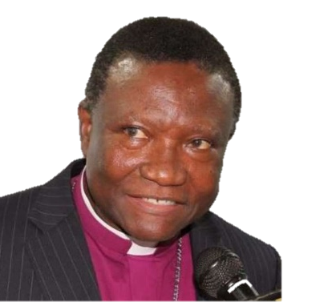
We will welcome our key note speaker, The Revd Prof Bishop Emmanuel Asante to frame our thoughts on holistic education within the Wesleyan community from an African perspective.
Then we will gather around tables to share good practice in holistic education and formation that:
- Holds together heart, soul, mind and body
- Promotes peace and justice and relational engagement
- Thinks globally, ecumenically or ecologically
- Practices what it teaches in its institutional life
Participants are invited to bring examples from their own educational and church contexts to discuss with others from around the world.
Call for Workshop Proposals
In the afternoon we want to offer a series of workshops that get beyond talking and give participants an experience of an aspect of holistic education from within our global Methodist community. You are invited to submit a workshop proposal for 20 people lasting 90 minutes. Workshops should be experiential and practical, i.e., not only presentations of the material but active engagement with the practices.
Proposals should be completed on the attached form and submitted to Revd Dr Adam Ployd at ap2287@wesley.cam.ac.uk by Thursday, 15 December 2022. E copies of the form can be found at: https://www.wesley.cam.ac.uk/transforminglives/
The number of workshops selected will depend on the number of delegates coming to the Conference. Proposals will be chosen to reflect a range of global perspectives, themes and means of participation. Delegates will be invited to choose 2 workshops to attend during the afternoon once they have registered for the Conference.

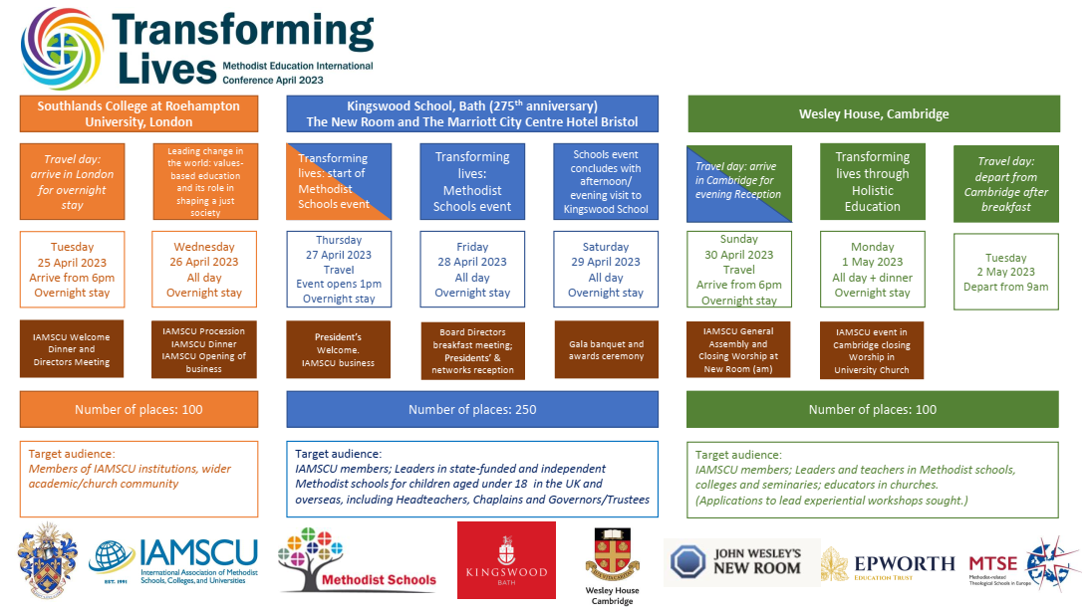
A Call to Holistic Global Education
Call for Workshop Proposals| 1 May 2023| Cambridge

Name of workshop leader(s)
Contact email and phone number
Institutional membership
Your country of origin
Brief description of the theme of your proposed workshop. Please show how the aim of this workshop connects with the theme of holistic global education (100 words)

Title of Workshop

Learning Aim(s) of Workshop. Please state what participants can expect to learn in the 90 minutes (100 words)

Short description of the ways in which participants will be invited to engage during the workshop (100 words)

Declaration
I intend to be present in person at the IAMSCU Symposium in Cambridge on 1 May 2023. By submitting this proposal I express my willingness to lead a workshop for up to 20 people for 90 minutes. I understand that workshops will be selected from amongst the applicants and that my application may not be accepted. I understand that I may be asked to run my workshop twice during that afternoon if there is sufficient demand.

Signed __________________________________________ Date __________________

